

**INSTALLATION MANUAL**

### **Table of Contents**

### **Applicable Version………………..…....……………………………….………………….2**

### **Configuring Worldline………………..………………………………………………….…6**

### **Feature List ……….....………………..………………………………………………………7**

### **Applicable versions**

| **Applications** | **Versions** |
| --- | --- |
| Java | 1.8 |
| Tomcat | 9 |

### **Basic Setup Configuration**

1. In server.xml of tomcat server, set value :

**relaxedPathChars='[]|' relaxedQueryChars='[]|{}^&#x5c;&#x60;&quot;&lt;&gt;'**

in the connector tag.

Example : <Connector connectionTimeout="20000" port="8080" protocol="HTTP/1.1" redirectPort="8443" relaxedPathChars='[]|'

relaxedQueryChars='[]|{}^&#x5c;&#x60;&quot;&lt;&gt;' />

1. In application.properties file set the location of the json file where admin page data needs to be stored.

### **Configuring Worldline**

1. Go-to http://<your-hostname>/payment/admin
2. Scroll down. You will see worldline, Edit it
3. Configure it as below:

| **Column Name** | **Description** |
| --- | --- |
| Merchant Code | Enter Merchant Code |
| Salt | Enter Salt. |
| Payment Type | For Test mode Select ‘Test’ and for Live mode select ‘Live’ |
| Merchant Scheme Code | Enter Scheme Code |

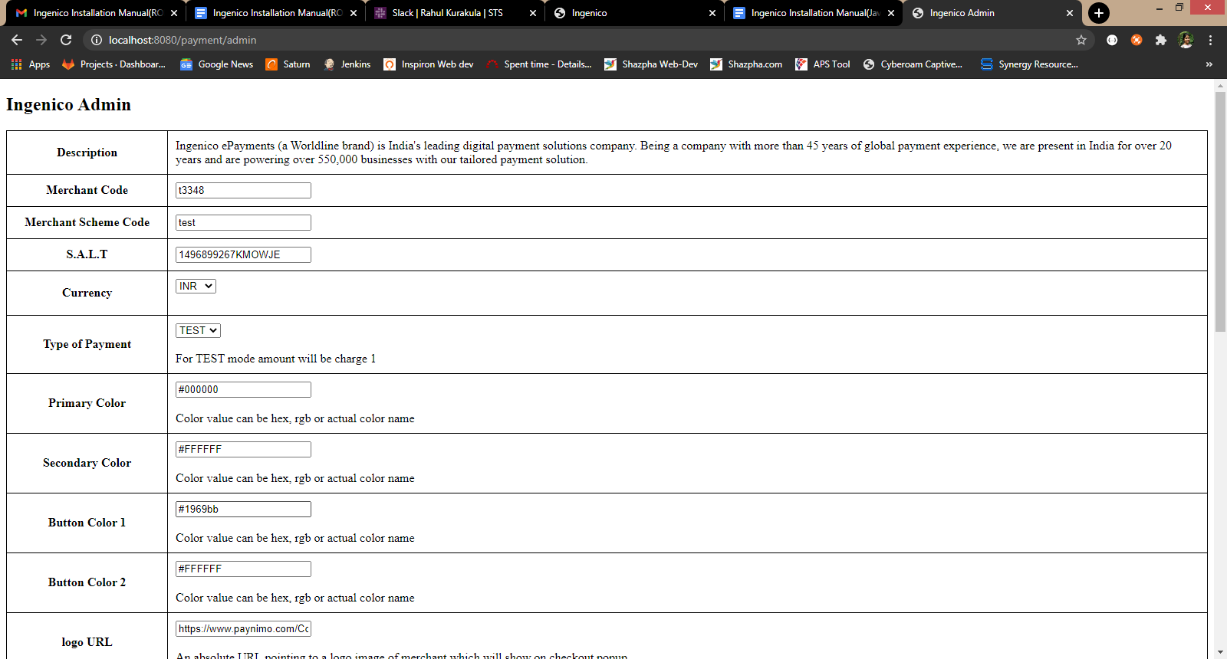

### **Advanced Configuration**

There are also some advanced configuration options you may consider as shown below:

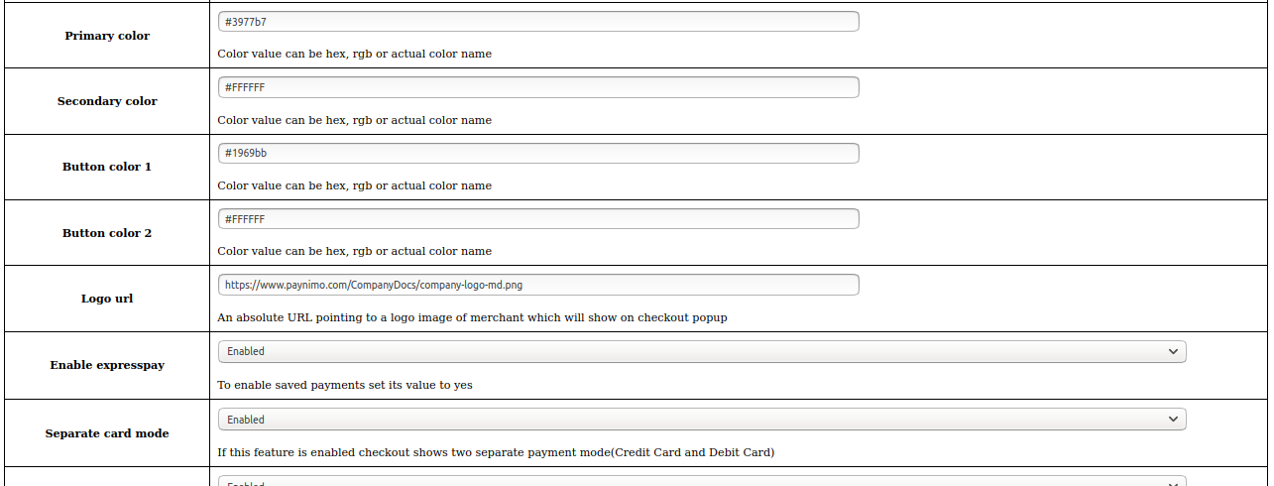

1. Now click on “Submit” at the bottom of the page
2. Worldline Payment Gateway is now configured & ready to use.

**Features List**

### **Online Transaction**

To make an online transaction go to http://<your-hostname

### **Dual verification of response**

We are validating responses with a hash value and call again Payment Gateway for dual verification from the payment gateway before updating to the order status.

### **Reconciliation**

Merchants can update the pending status of the order automatically if the payments are successful. This page can be found at [http://<your-hostname>/payment/reconcile](http://localhost:3000/payment/reconcile)

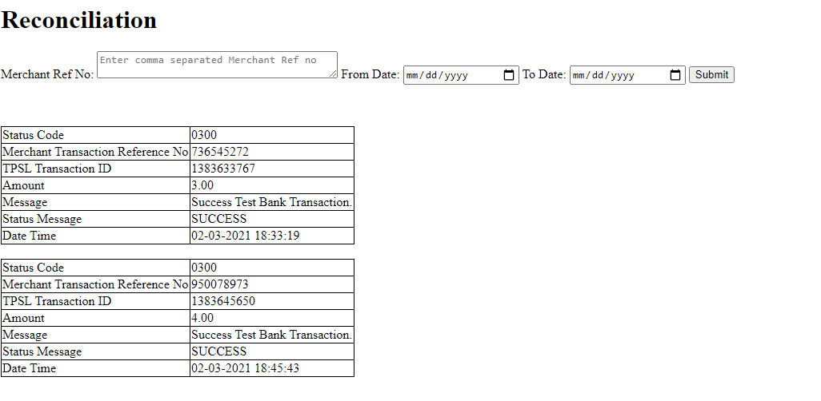

### **S2S Verification**

If we do not receive any response from the payment gateway then after 30 mins, we will get

a response from the server and based on the response it will update order status.

To configure S2S URL, contact prod team.

S2S url format : http://<your-hostname>/payment/s2s?msg=

Example:

http://<your-hostname>/payment/s2s?msg=0300|success|NA|4565666|470|1364637998|5.00|{email:[test@test.com](mailto:test@test.com)}{mob:9876543210}|08-02-2021%2015:20:19|NA||TEST%20BANK|1111364637998||984ac060-eea8-4c01-a7e4-c3dc9184073b|7366ccdf630d883c56ce6ec517d55d456c1a6f6de6f23acefb82229cf023bd8eabec2472d840030f538939e29f046ea63e4bdff73968d4866fe504ccc3329ec3

### **Offline Verification**

Merchants can verify the status of their payment by using the Payment Verification page. The payment verification page can be found at [http://<your-hostname>/payment/](http://localhost:3000/payment/offline-verification)offlineVerification

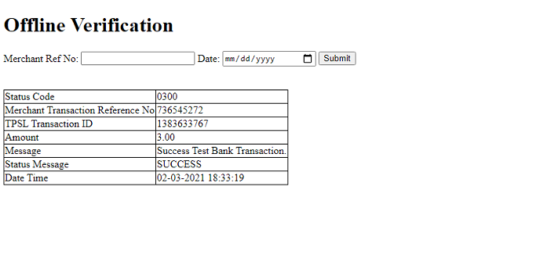

### **Refund**

Merchants should be able to process the refund online for the order whose payment has been done via Worldline.

To refund an order go to [http://<your-hostname>/payment/refund](http://localhost:3000/payment/refund)

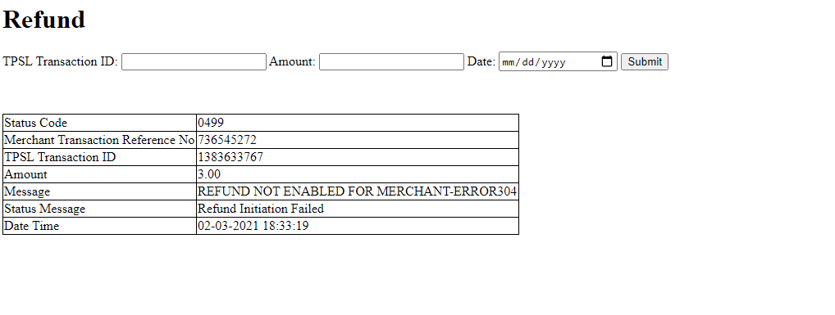

### **Embed Payment Gateway**

After enabling this setting, payment gateway displays like embedded on the page instead of pop-up so user experience would be good.

**E-mandate/E-Nach/SI**

**Configuration**

1. Go-to http://<your-hostname>/payment/admin
2. Configure it as below

| **Column Name** | **Description** |
| --- | --- |
| Enable SI | “Enable” this flag to use E-mandate/E-nach/SI |

1. Now click on “Submit” on the bottom.
2. Worldline Payment Gateway with E-mandate is now configured & ready to use.

**Advanced Configuration**

There are also some advanced configuration options you may consider as shown below:

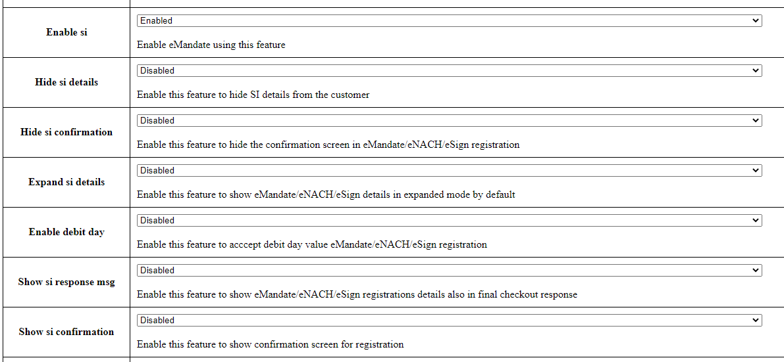

**Mandate Registration**

1. Go-to http://<your-hostname>
2. Fill the necessary fields for transaction
3. Click on “Save” button to get the E-mandate Pop up
4. Fill the necessary fields on pop -up and click complete the transaction to register the mandate

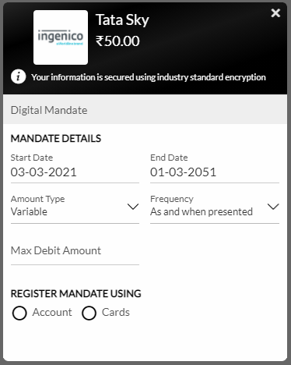

## **Features List**

### **Mandate Verification**

Merchants can verify the status of their Registered Mandate/SI by using the Mandate Verification page.

The Mandate verification page can be found at

[http://<your-hostname>/emandate-si/mandate-verification](http://localhost:3000/payment/offline-verification)

We need to pass Consumer ID used in Online Transaction

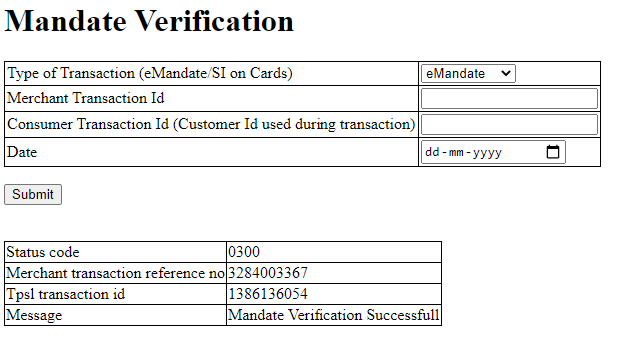**Transaction Scheduling**

Merchants can Schedule their Transaction for Mandate/SI by using the Transaction Scheduling page.  
The Transaction Scheduling page can be found at

[http://<your-hostname>/emandate-si/transaction-scheduling](http://localhost:3000/payment/offline-verification)

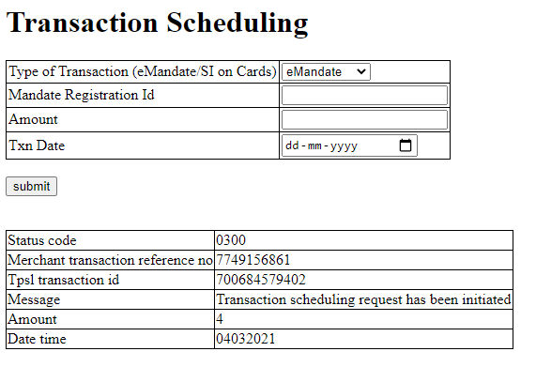**Transaction Verification**

Merchants can verify the status of their Scheduled Transaction for Mandate/SI by using the Transaction Verification page.

The Transaction Verification page can be found at

[http://<your-hostname>/emandate-si/transaction-verification](http://localhost:3000/payment/offline-verification)

We need to pass the Merchant Transaction Reg No given in Transaction Scheduling response

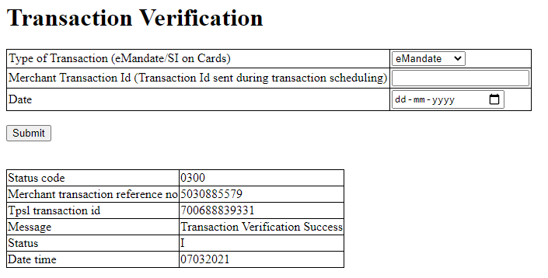

### **Mandate Deactivation**

Merchants can deactivate the registered Transaction for Mandate/SI by using the Mandate Deactivation page.

The Mandate Deactivation page can be found at

[http://<your-hostname>/emandate-si/mandate-deactivation](http://localhost:3000/payment/offline-verification)

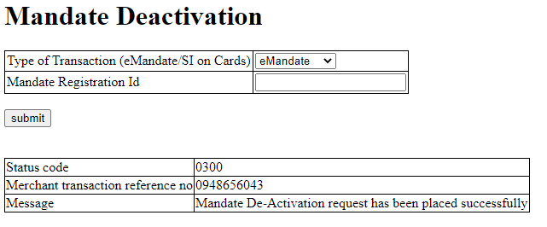

### **Stop Payment**

Merchants can Stop the scheduled transaction by using the Stop Payment page.

The Stop Payment page can be found at

[http://<your-hostname>/emandate-si/stop-payment](http://localhost:3000/payment/offline-verification)

We need to pass TPSL Transaction ID given in Transaction Scheduling response

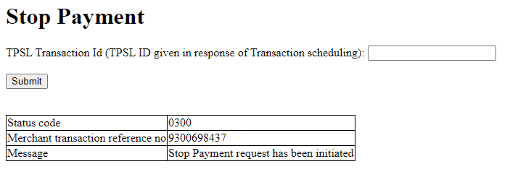**Documentation link**

[**https://www.tecprocesssolution.com/proto/p2m/client/salt-based-documentation.htm#online**](https://www.tecprocesssolution.com/proto/p2m/client/salt-based-documentation.htm#online)